Automated File Classification and Organization System

Introduction:
In today’s digital world, computers store a large number of files, including documents, images, videos, audio files, and program files. Managing these files manually can be time-consuming and may lead to unorganized folders, difficulty finding important files, and confusion due to duplicate filenames.
The Automated File Classification and Organization System Using C++ is designed to solve these problems by automatically classifying and organizing files according to their extensions. The system uses C++ filesystem operations to identify file types, create suitable folders, and move files into categories such as Documents, Images, Videos, Audio, Code, and Others. It also handles duplicate filenames without overwriting existing files.
This project demonstrates the practical use of file handling, directory management, and filesystem operations in C++. It reduces manual effort, saves time, improves file accessibility, and provides a systematic approach to managing digital files efficiently.

Problem Statement:
To design and implement an Automated File Classification and Organization System using C++ to improve traditional file management methods. Managing a large number of files manually can lead to disorganized folders, difficulty locating important documents, and unnecessary time consumption. The proposed system aims to automate file classification by identifying file extensions and arranging files into appropriate folders, such as Documents, Images, Videos, Audio, Code, and Others. It uses C++ filesystem operations to create folders, move files, and handle duplicate filenames without overwriting existing data. The system provides a structured and efficient approach to file organization, reduces manual effort, improves file accessibility, and demonstrates the practical application of file handling and filesystem management in C++ programming.

Objectives :-
- To develop an automated file classification and organization system using C++.
- To classify files based on their extensions, such as documents, images, videos, audio, and code files.
- To automatically create folders for different file categories.
- To move files into their respective folders and maintain an organized directory structure.
- To handle duplicate filenames without overwriting existing files.
- To reduce manual effort and save time in file management.
- To improve file accessibility and demonstrate the practical application of C++ filesystem operation.

Algorithm:

1. Start the program and initialize the required variables and filesystem operations.
2. Ask the user to enter the directory path containing the files to be organized.
3. Check whether the specified directory exists and is valid. If the directory is invalid, display an error message and terminate the program.
4. Read the files available in the specified directory using C++ filesystem operations.
5. Select each file individually and check whether it is a regular file. Ignore directories and other non-regular entries.
6. Extract the file extension and convert it to lowercase to ensure consistent classification regardless of letter case.
7. Identify the category of the file based on its extension, such as Documents, Images, Videos, Audio, Code, or Others.
8. Create the appropriate destination folder inside the selected directory if it does not already exist.
9. Construct the destination path by combining the category folder with the original filename.
10. Check whether a file with the same name already exists in the destination folder. If a duplicate exists, skip the file to prevent overwriting existing data.
11. If no duplicate exists, move the file into its corresponding destination folder using filesystem operations.
12. Display the filename and destination category after a successful file movement. If an operation fails, handle the error appropriately.
13. Repeat the classification and organization process for all remaining regular files in the selected directory.
14. Maintain counters for successfully organized files and skipped files to prepare the final summary.
15. Display the organization summary, including the number of files organized and the number of files skipped.
16. Display a completion message indicating that the file organization process has finished.
17.Stop the program.

Flowchart:
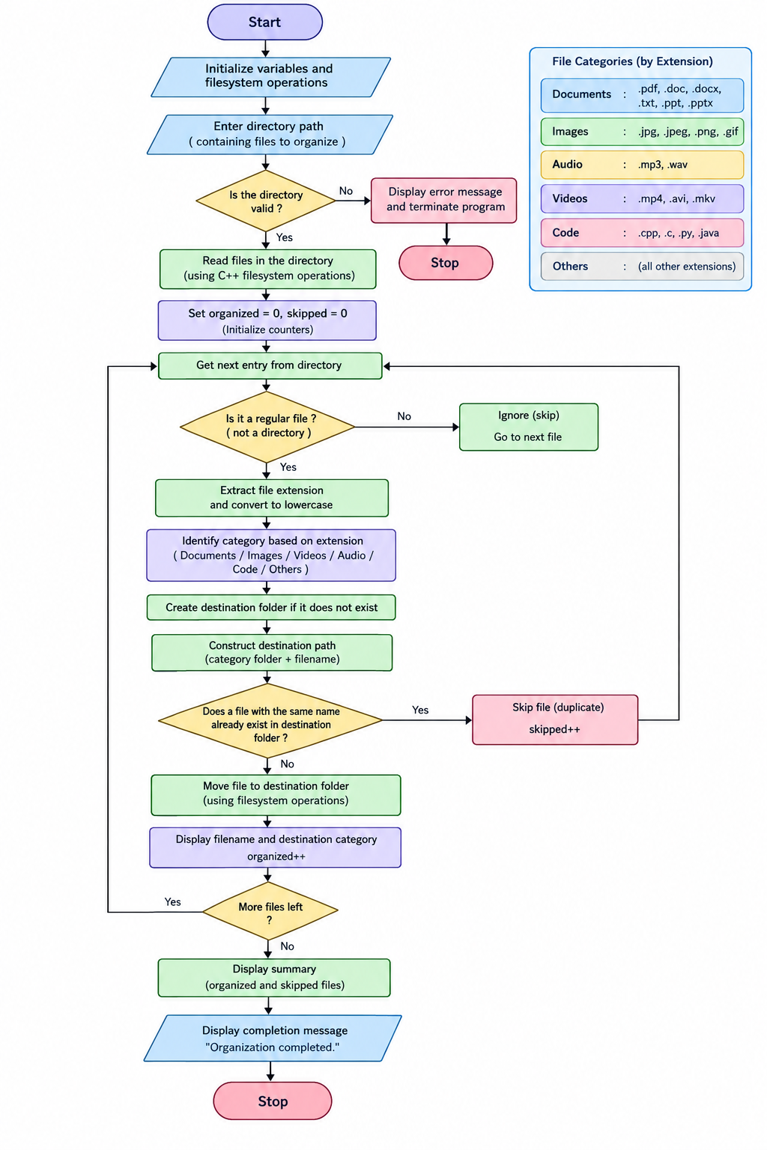

Conclusion:-
The Smart File Organizer Using Singly Linked List project demonstrates how linked lists can be used to store and manage file and folder names dynamically. The system allows users to add new entries, display all entries, search for a particular name, delete an entry, and count the total number of entries.This project helps in understanding important concepts of C++ programming, such as pointers, structures, dynamic memory allocation, and linked-list operations. It also shows the advantages of linked lists when the number of entries changes frequently.In conclusion, this project provides a simple and effective way to organize file and folder names in program memory. In the future, it can be enhanced to work with actual files and folders on a computer and provide advanced features such as sorting, categorization, and automatic file organization.

